Complete the chart with the sentence in passive voice.
active | John wrote an amazing story about robots.
passive | An amazing story about robots was written by John
negative passive | _______ wasn‘ t written_________
question passive | Was an amazing story about robots written by John?
active | The goverment will support the poor people.
passive
negative passive
question passive
active | Someone has stolen my car twice.
passive
negative passive
question passive
active | We throw a lot of waste every day.
passive
negative passive
question passive

Choose the correct form of the verbs in brackets.
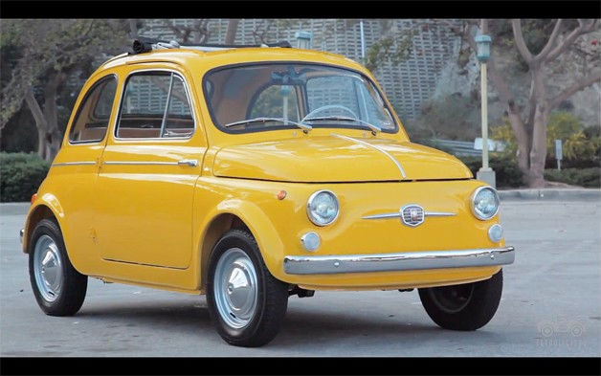
FIAT
Fiat 0 was started (started/was started) by a group of Italian businessmen in 1899. In 1903, Fiat, 1_________________ (produced/was produced) 132 cars. Some of these cars 2_____________________ (exported/were exported) by the company to the United States and Britain. In 1920, Fiat 3 _________________ (started/was started) making cars at a new factory at Lingotto, near Turin. There was a track on the roof where the cars 4 ____________________ (tested/were tested) by technicians. In 1936, Fiat launched the Fiat 500. This car 5 ____________________ (called/was called) the Topolino – the Italian name for Mickey Mouse. The company grew, and in 1963 Fiat 6 _____________________ (exported/was exported) more than 300,000 vehicles. Today, Fiat is based in Turin, and its cars 7 _________________ (sold/are sold) all over the world.

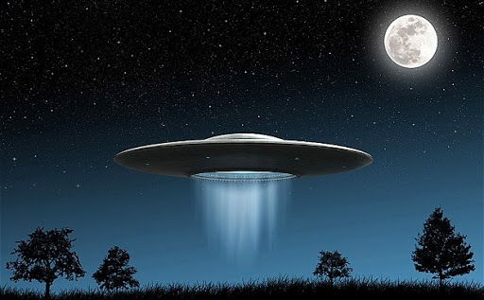
Imagine you work in News. Most of the articles must be in passive voice.
Rewrite the following passage in the Passive.
Some people saw a UFO in the sky above London last night. They reported it to the police. The army sent a helicopter to look at it more closer. The UFO shot the helicopter down and killed both men in it. People have given photographs of the UFO to the police. Experts are looking at them now. ____________________________________________________________________________________ ____________________________________________________________________________________ ____________________________________________________________________________________ ____________________________________________________________________________________ ____________________________________________________________________________________

